
139 Acadian Lane
Mandeville, Louisiana 70471
` (985)845-9829/(504)430-7117

M/V DALLAS J. ADAMS
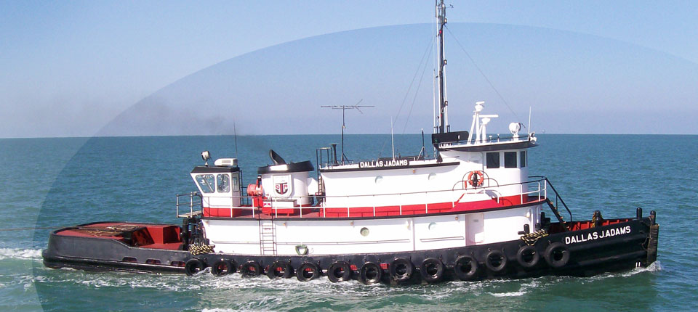
VESSEL SPECIFICATIONS

TYPE: Towing & Anchor Handling QUARTERS: 4
YEAR BUILT: 1969 CREW MEMBERS: 10
YEAR REBUILT: 1985 repowered PASSENGERS: No
FLAG: USA S.S.B.: SBA 312
CLASS: ABS Loadline S.S.B.: Necode Model Sea 112
SIZE: 103’ x 27’ x 12’ VHF: Raytheon Model Ray 53A
DRAFT: 11’10” (min draft 10.5’) VHF: Modar Intan 55-75
RATED HP: 4200 COMPANY FM: Motorolla
GROSS TONS: 192.08 RECEIVER: None
NET TONS: 130 ADF: None
ENGINES: (2) CAT 3516 SATELLITE NAV: None
RED. GEARS: (2) CAT 7271 LORAN: Sitex
GENERATORS: (2) Delco 40 Kw FATHOMETER: Kodiak Data Marine
GEN. ENGINES: (2) GM 471 RADAR: (2) EPSCO E.M. M-18
FREE RUN SPEED: 12.6 Knots MAG COMPASS: Baker Lyman
FUEL CAPACITY: 30,000 gallons GYRO: Sperry Mark 27
LUBE OIL: 700 gallons AUTO PILOT: Sperry
POTABLE WATER: 6,000 gallons WINCH: Intercon Single Drum 307
WATER MAKER: None WIRE LTH/SIZE: 2000’ x 1 ¾”
WHEEL SIZE: 78” x 66” 4 blade SS LINE PULL: 150,000 lbs Stal

(Details and specifications as per Owner and not guaranteed by Broker.)

